PROJECT DOCUMENTATION
AI WEATHER WISE API

1.INTRODUCTION :
- TITLE: AI-Augmented Backend Development - A&S
- TEAM ID: SWTID-2026-1735
- TEAM LEADER: Reshma S &sathyabalan112018@gmail.com
- TEAM MEMBERS:
- Vidya Varshini S & varshaasuresh2007@gmail.com
- Varunikaa P & vvarunikaa2006@gmail.com
- Akshaya N & akshayanithyaprakash@gmail.com

2.PROJECT OVERVIEW:

AI WeatherWise is an AI-powered weather application designed to provide users with real-time and easy-to-understand weather information. The system uses a Weather API to collect important data such as temperature, humidity, wind speed, atmospheric pressure, rainfall, and weather conditions for a selected location. The collected data is processed and displayed through a simple and user-friendly dashboard.
The main purpose of AI WeatherWise is to make weather information more useful than a traditional weather application. By using AI-based analysis, the system can interpret weather conditions and provide simple insights and alerts to users. It can help users plan their daily activities, travel, outdoor events, and other weather-dependent activities.
The project can be developed using technologies such as HTML, CSS, JavaScript, Python, and a suitable Weather API. The backend handles API communication and data processing, while the frontend displays the weather information using charts, icons, and forecast details. Future improvements can include personalized weather alerts, historical weather analysis, voice-based assistance, and advanced weather prediction features.
Overall, AI WeatherWise combines Weather API, data processing, and Artificial Intelligence to create a smart, reliable, and user-friendly weather monitoring system.

3. PROJECT OBJECTIVES:
The main objective of AI WeatherWise is to provide users with accurate and real-time weather information using a Weather API. The system aims to collect important weather parameters such as temperature, humidity, wind speed, pressure, and rainfall and present them in a simple and user-friendly format.
Another objective is to use Artificial Intelligence to analyze the collected weather data and generate meaningful weather insights. The system can provide forecasts, identify changing weather conditions, and generate alerts to help users understand possible weather changes.
AI WeatherWise also aims to provide location-based weather information through an interactive dashboard with charts, icons, and forecast details. This helps users easily monitor weather conditions and plan their daily activities, travel, and outdoor events.
Overall, the project aims to develop a smart, reliable, and efficient weather monitoring system by combining Weather API integration, data processing, AI analysis, and an easy-to-use interface.

4.SYSTEM ARCHITECTURE:
1. User Interface:
The user interacts with the AI WeatherWise application through a simple interface.
Users can enter a city or location to check weather conditions.
The interface displays temperature, humidity, wind speed, and forecast details.
It provides the weather information in an easy-to-understand format.
2. Backend System:
The backend manages communication between the user interface and weather API.
It receives the user's location and sends a request for weather information.
The retrieved data is processed and organized by the backend system.
It also manages AI analysis and weather alerts.
3. Weather API:
The Weather API provides real-time weather information for the selected location.
It supplies parameters such as temperature, humidity, pressure, and wind speed.
The API can also provide rainfall and forecast information.
This data becomes the main input for the AI WeatherWise system.
4. Data Processing and AI Module:
The collected weather data is cleaned, processed, and analyzed by the system.
The AI module identifies weather patterns and interprets the collected information.
It can generate simple weather insights and identify changing conditions.
The processed results are then prepared for display to the user.
5. Output and Alerts:
The final weather information is displayed through the application dashboard.
Users can view current conditions, forecasts, and AI-generated insights.
The system can also provide alerts for significant weather changes.
This helps users understand weather conditions and plan their activities.

5.KEY FEATURES :
1. Real-Time Weather Updates:
AI WeatherWise provides real-time weather information using a Weather API.
It displays current temperature and other important weather conditions.
The data is updated regularly to provide the latest information.
Users can easily check the weather for their selected location.
2. Location-Based Forecast:
The system provides weather information based on the user's selected location.
Users can search for a city or specific location to view its weather.
It provides current conditions along with upcoming forecasts.
This makes the application useful for different locations.
3. AI Weather Analysis:
AI WeatherWise uses Artificial Intelligence to analyze weather data.
The system processes different weather parameters and identifies conditions.
It converts complex weather information into simple insights.
This helps users understand the weather more easily.
4. Weather Alerts:
The system can provide alerts when significant weather changes occur.
Users can receive information about rainfall, strong winds, or other conditions.
These alerts help users become aware of possible weather changes.
It supports better planning and preparedness.
5. Interactive Dashboard:
The application displays weather information through a simple dashboard.
Temperature, humidity, wind, and rainfall can be shown using visual elements.
Charts and weather icons make the information easier to understand.
The user-friendly design provides quick access to important weather details.
system. Error handling mechanisms are implemented to manage exceptions and provide meaningful responses to the client.

6.TECHNOLOGY STACK:
- Frontend Technologies:
HTML, CSS, and JavaScript can be used to develop the user interface.
The frontend displays weather details, forecasts, icons, and charts.
It provides an interactive interface for searching different locations.
The design focuses on simplicity and easy navigation.
- Backend Technologies:
Python can be used to develop the backend of AI WeatherWise.
Flask or FastAPI can handle communication between the frontend and API.
The backend processes user requests and weather information.
It also manages data processing and AI-related functions.
- Weather API:
A Weather API is used to retrieve real-time weather information.
It provides temperature, humidity, wind, pressure, and rainfall data.
The API also supports forecast information for selected locations.
This allows the application to work with continuously updated weather data.
- AI and Machine Learning:
Python-based AI and Machine Learning techniques are used for weather analysis.
Libraries such as NumPy and Pandas can process the collected data.
Machine Learning models can identify patterns in weather conditions.
AI analysis helps generate useful weather insights and alerts.
- Database and Visualization:
MySQL or MongoDB can be used to store weather and historical data.
The system can maintain previous weather records for future analysis.
Charts and graphs can visualize temperature, rainfall, and other parameters.
This makes weather trends easier for users to understand.

7.DATABASE DESIGN :
AI WeatherWise uses a structured database to store, organize, and manage weather-related information efficiently. The database stores important details such as location, temperature, humidity, wind speed, atmospheric pressure, rainfall, weather conditions, and forecast details. This information can be collected from the Weather API and stored for further processing and analysis.
Each weather record is maintained with the corresponding location, date, and time of data collection. This helps the system identify when and where the weather information was recorded. The database structure allows the application to quickly retrieve the latest weather information whenever a user searches for a particular location.
The system can also maintain historical weather records for different locations. These records can be used to compare current weather conditions with previous data and understand changes or patterns over time. Historical information can also support the development and improvement of AI-based weather analysis features.
The stored weather data is accessed by the backend and AI module for processing and analysis. The AI module can use the available information to generate weather insights, identify changing conditions, and support prediction features. Overall, the database provides a reliable foundation for storing weather information and helps AI WeatherWise deliver accurate, organized, and useful weather information to users.

8.API ENDPOINTS :
AI WeatherWise uses API endpoints to communicate between the application and the weather service. These endpoints allow the system to request current weather conditions, forecasts, and other weather-related information. The backend sends requests to the API using the required location and API key. The received response is generally provided in JSON format and is then processed by the application.
The Current Weather endpoint is used to retrieve the latest weather conditions for a particular city or location. It provides important details such as temperature, humidity, wind speed, atmospheric pressure, cloud conditions, and weather description. This information is displayed to the user through the dashboard.
The Forecast endpoint is used to obtain upcoming weather information for a selected location. It can provide hourly or daily forecast details depending on the API service being used. The system processes this information to display expected temperature, rainfall, wind conditions, and other forecast details.
The Location or Geocoding endpoint can be used to convert a city name or location into geographical coordinates such as latitude and longitude. These coordinates are then passed to the weather API to retrieve accurate weather information. This helps AI WeatherWise support weather searches for different cities and locations.

9.AI WEATHER WISE USING API
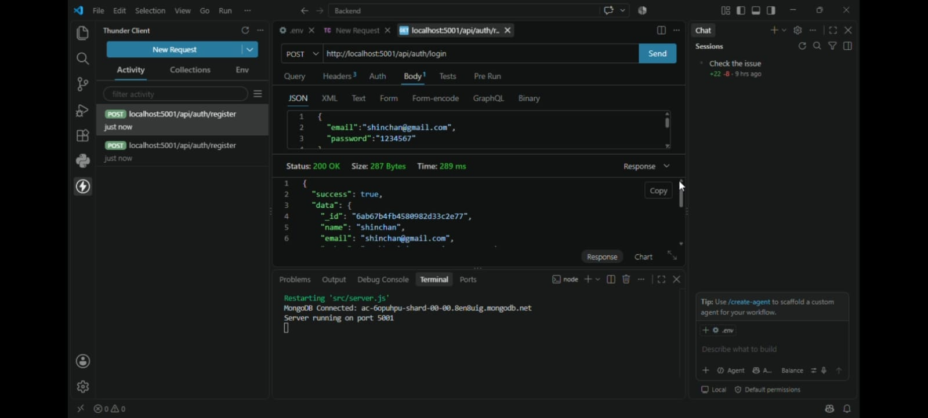

TEMPERATURE VALIDATING:
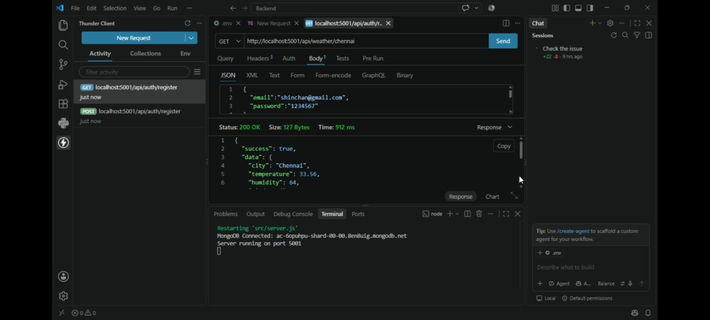
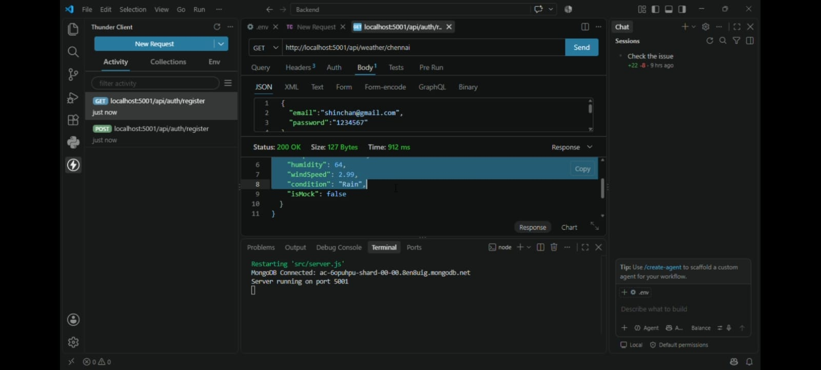

FINAL OUTPUT :
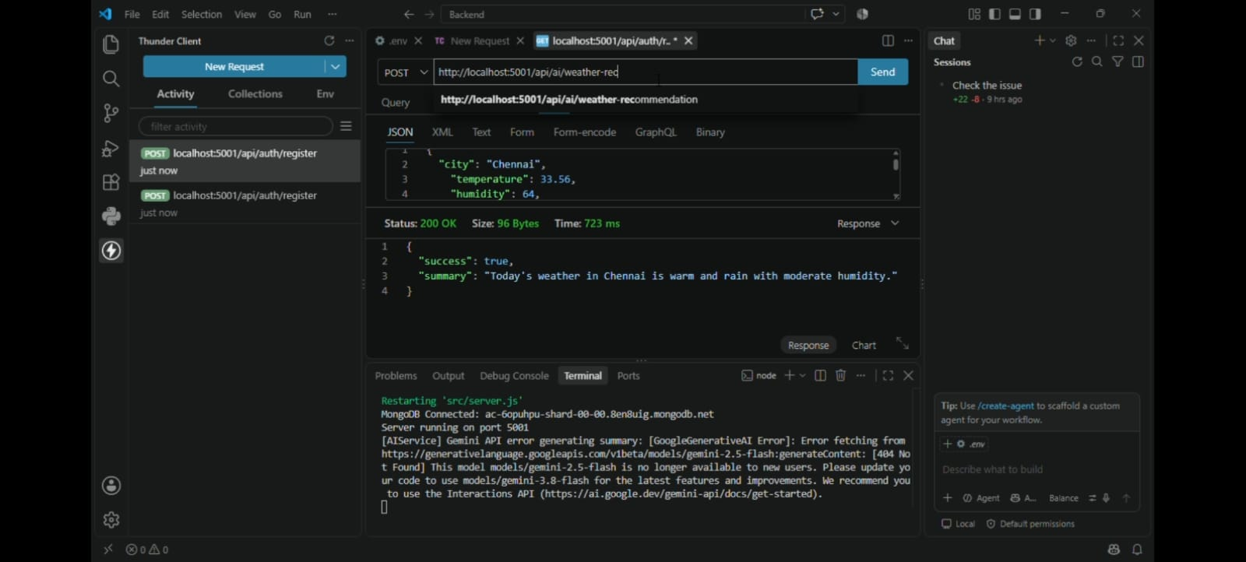

10.PROJECT EXECUTION:
The AI WeatherWise project is executed by first designing a simple and user-friendly interface for entering a city or location. The frontend is developed using HTML, CSS, and JavaScript to display weather information, forecasts, icons, and other details. The interface is designed to make the application easy to use and understand.
The next step is integrating the Weather API with the backend system. When the user enters a location, the backend sends a request to the API and receives the required weather information. The API response is processed to extract parameters such as temperature, humidity, wind speed, pressure, rainfall, and weather conditions.
After collecting the weather data, the system performs data processing and AI-based analysis. The collected information is cleaned, organized, and analyzed to identify weather conditions and generate useful insights. The AI module can also support weather alerts and prediction features based on the available data.
Finally, the processed information is displayed through the AI WeatherWise dashboard. Weather conditions are represented using suitable charts, icons, and forecast details for better understanding. The complete system is tested for API connectivity, data accuracy, user input, response time, and proper display of weather information before deployment.

11.CONCLUSION:

AI WeatherWise is an intelligent weather monitoring system that combines Weather API, data processing, and Artificial Intelligence to provide useful weather information. The system can collect real-time weather data such as temperature, humidity, rainfall, wind speed, and atmospheric pressure and present it through a simple dashboard.
By analyzing the collected data, AI WeatherWise can provide weather insights, forecasts, and alerts to users. The system helps users understand changing weather conditions and supports better planning for daily activities, travel, and outdoor events.
The project provides a strong foundation for developing a smarter weather application with future features such as advanced prediction models, personalized alerts, historical weather analysis, and voice-based assistance. Overall, AI WeatherWise demonstrates how API integration and AI technology can be effectively used to build a practical and user-friendly weather solution.

